**LAWRENCE LAPHAM**

**COACH**

**Lawrence “Larry” Lapham coached three different sports in a career spanning the years from 1945 to 1969. Two years with the Boys’ Basketball Program was followed by twenty-one years with the Girls’ Program. He also coached Baseball for over twenty years. His accomplishments are as follows:**

1. **Larry’s Girls’ Basketball Teams compiled a record of 315 wins -53 losses.**
2. **Larry coached for four undefeated seasons (1951-52, 1954-55, 1955-56, and 1956-57).**
3. **York Girls’ Basketball won 16 Conference Championships under his tutelage. There were no State Championships played at that time.**
4. **There were five State Foul Shooting Champions developed by Coach Lapham.**
5. **His baseball teams won 179 games**
6. **Larry’s Baseball Teams won two Western Maine Championships in 1954 and 1969.**
7. 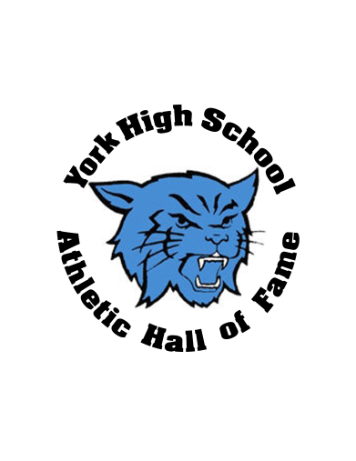**Larry also served as the girls’ JV Basketball Coach, compiling a 163-32 record.**