**RICHARD LABONTE**

**CLASS OF 1981**

**Richard “Rich” LaBonte was a true multi-sport all-star, having competed at York in Baseball, Football, Track, and Basketball. One of the greatest football players to ever play at York, he was also known for his success in basketball and track. The following list indicates his success.**

1. **Rich was selected to the All-Conference team in Football a total of seven times at three different positions.**
2. **He set the all-time passing record at York while leading his team to the 1980 State Championship as its quarterback.**
3. **In Basketball, he was the starting point guard for three years and helped the team to a Western Maine Runner-up finish in 1981.**
4. **He was voted to the All-Conference All-Star team in Basketball in his senior year and played in the East-West All-Star Game at the state level.**
5. **His first two years in Baseball he was a starter in the infield.**
6. **As a Track athlete, Rich was a multi-event performer who was a part of the State Championship 400 Meter Relay team that set the state record that still stands today (43.8 sec.)**
7. **Rich was named an honorable mention All-American in Track in 1981**
8. 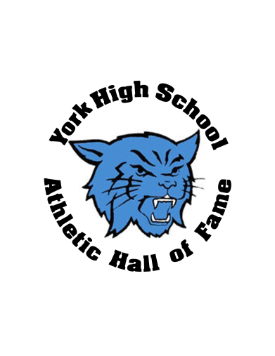**Rich captained the Football, Basketball, and Track teams in his senior year.**
9. **His senior year, he helped the Track team to a State Runner-up finish.**